SANDWICH

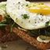
Change
Avocado Mozzarella Egg Sourdough Sandwich
The all day sandwich.
8,00 EUR
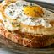
Change
Crock Madam
Our idea of the ultimate brunch dish – pork bistro ham alongside with creamy béchamel, melted cheese, with a perfectly runny egg on top.
8,00 EUR
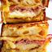
Change
Chicken Bacon Sourdough Sandwich
Grilled Gruyère or Emmental cheese sandwich with the addition of chicken and bacon.
8,50 EUR
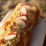
Change
Prawn and Crab French Baguette
Fresh marinated prawns with cocktail crab sauce and fresh green leaf ev salat on a crispy French baguette.
9,00 EUR
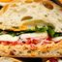
Change
Ciabatta Prosciutto Mozzarella
Ciabatta bread topped with a tangy & spicy spread, sliced & salted tomatoes, mozzarella, prosciutto di Parma and a simple lemon arugula salad.
10,00 EUR
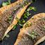
Change
Sea Bass Fillet Open Sourdough
The sauce is made from garlic, shallot, olive oil, lemon juice, chopped tomato and chopped herbs. Fresh, light and packed with flavor!
12,00 EUR
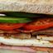
Change
Traditional Triara Mix Sandwich
The All-Time favorite sandwich for Cypriots, made with Halloumi, Bacon, Ham, Salami, Roast Pork. Using triares buns is a must and increases the legitimacy of calling this sandwich Traditional.
6,50 EUR
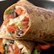
Change
Burrito
Flour tortilla wrapped with chicken fillet, bell pepper, shallot, avocado, sour cream.
8,50 EUR
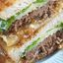
Change
Meatloaf Triara Sandwich
Beef meatloaf, edam cheese, caramelized onion, cucumber, tomato.
8,50 EUR
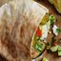
Change
Chicken fillet in Pita bread
Grilled chicken, lettuce, tomato, gurkens , boiled egg, special sauce.
8,50 EUR
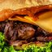
Change
Burgers
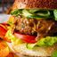
Change
Beef Burger
Homemade beef patty, mixed lettuce, tomato, gherkins, bacon, BBQ sauce, cheddar cheese.
10,50 EUR
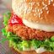
Change
Chicken Burger
Homemade crispy chicken fillet,letuce, tomatto,homemade sauce.
9,00 EUR
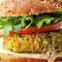
Change
Vegetarian Burger
Cauliflower, Potato, Green Peas, Sweet Corn
8,50 EUR
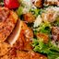
Change
Salads
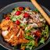
Change
Cesar Salad
Lettuce, bacon, crotons, chicken, parmesan cheese, homemade Cesar sauce, cherry tomato
8,50 EUR
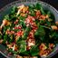
Change
Rokka Salad
Baby Roka, grilled haloumi cheese, pomegranate, walnuts, cherry tomato, avocado, granola.
8,50 EUR
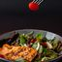
Change
Salmon
Mixed green leaves, grilled salmon, avocado, shallot, pumpkin seeds, mango.
10,50 EUR
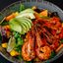
Change
Salad with Prawns
Mixed green leaves, avocado, mango, grilled prawns, peanuts
10,50 EUR
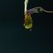
Change
Tuna Salad
Baby lettuce, tuna fish, shallot, cucumbers, carrots, cherry tomato, green bell pepper.
9,00 EUR
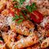
Change
Pasta
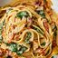
Change
A La Carbonara
Bacon, Mushroom, Onion, Garlic, Fresh Cream, Parmigiano
9,00 EUR
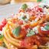
Change
Napoletana
Tomatoes, Onion, Garlic, Carrots, Herbs
8,00 EUR
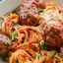
Change
Meat balls with tomato sauce
10,00 EUR
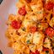
Change
Seafood
Prawns, Mussels, Salmon, Cherry Tomatoes, Fresh Cream
10,50 EUR

Side dishes
Breaded chicken fillet fingers
Breaded chicken breast with fried potato.
7,50 EUR
Fish fingers
Breaded white fish fillets with fried potato.
7,50 EUR
Wedges potatoes
4,00 EUR
Soft Drinks
Coca cola, Sprite, Fanta
Coca cola, Sprite, Fanta
1.50 EUR

